**The Power of CSS**

* CSS describes how HTML elements are to be displayed on screen, paper, or in other media
* CSS saves a lot of work. It can control the layout of multiple web pages all at once
* External stylesheets are stored in CSS files

## **CSS Used:**

CSS is used to define styles for your web pages, including the design, layout and variations in display for different devices and screen sizes.

## **Why CSS ?**

HTML was NEVER intended to contain tags for formatting a web page!

HTML was created to describe the content of a web page, like:

<h1>This is a heading</h1>

<p>This is a paragraph.</p>

When tags like <font>, and color attributes were added to the HTML 3.2 specification, it started a nightmare for web developers. Development of large websites, where fonts and color information were added to every single page, became a long and expensive process.

To solve this problem, the World Wide Web Consortium (W3C) created CSS.

CSS removed the style formatting from the HTML page!

## **Saves lots of time:**

The style definitions are normally saved in external .css files.

With an external stylesheet file, you can change the look of an entire website by changing just one file!

1. **First Example**

**Inserting the Style Sheet**

There are three ways of inserting a style sheet:

1. External style sheet
2. Internal style sheet
3. Inline style

## **1.1 Inline Styles**

An inline style may be used to apply a unique style for a single element.

To use inline styles, add the style attribute to the relevant element. The style attribute can contain any CSS property.

The example below shows how to change the color and the left margin of a <h1> element:

### **Example:**

<h1 style="color:blue;margin-left:30px;">This is a heading</h1>

**Looks Like:**



**1.2 Internal Style Sheet**

An internal style sheet may be used if one single page has a unique style.

Internal styles are defined within the <style> element, inside the <head> section of an HTML page:

### **Example:**

<head>

<style>

body {

background-color: linen;

}

h1 {

color: maroon;

margin-left: 40px;

}

</style>

</head>

**Looks Like:**

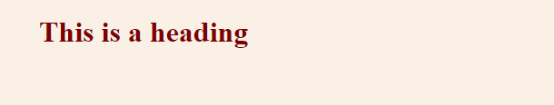

**1.3 External Style Sheet**

With an external style sheet, you can change the look of an entire website by changing just one file!

Each page must include a reference to the external style sheet file inside the <link> element. The <link> element goes inside the <head> section:

### **Example**

<head>

<link rel="stylesheet" type="text/css" href="mystyle.css">

</head>

**mystyle.css file:**

body {

background-color: lightblue;

}

h1 {

color: navy;

margin-left: 20px;

}

**Looks Like:**

